

2025 – 2026 Business & Operational Plan
(April 1, 2025 – March 31, 2026)
Contents
Executive Summary 1
Fiscal 2024-2025 Outcome Highlights 3
Board of Directors 5
Staffing 6
Current Staff 6
Explorers’ Edge Vision, Mission and Mandate: 8
Industry Scan: 9
Provincial Travel Indicators 9
Occupancy Data 11
Historical Occupancy Review: 2008 - 2022 12
Macro Environment 13
Region Specific Data/Skift Advisory: 14
Climate Impact 14
Regenerative Review: Staying the Course in an Uncertain World 15
Priority Projects: 2025-2026 17
Explorers’ Edge 2025-2026 Government Pillars 19
High Level Goals for Each Pillar 21
Explorers’ Edge Consumer Marketing Plan 23
2025 - 2026 Business & Operational Plan Summary 25
2025 – 2026 BOP: Objectives, Key Activities and Timelines, Performance Measures 26
Governance 26
Marketing 30
Product Development 32
Investment Attraction 34
Workforce 35
Partnership 36
Fiscal 2025 / 2026 Budget 37

Figure 1. 2025-2026 Organizational Chart 6
Figure 2. CRBE Eleven Months Ended November 2024 11
Figure 3. Historical Occupancy Review: 2008 - 2022 12
Figure 4. Region-Centric Regenerative Tourism Approach, 2021 15
Figure 5. Destination Development Organization 16

Executive Summary
Established in 2010 by the Ontario Ministry of Tourism, Culture & Gaming (MTC&G), Explorers’ Edge (EE) is one of eleven Regional Tourism Organizations (RTOs) in the province. Representing stakeholders in the geographic areas of Algonquin Park, the Almaguin Highlands, Loring-Restoule, Muskoka, west Parry Sound district and South Algonquin, Ontario, Canada, the company is governed by an independent Board of Directors. The region is located on the traditional lands and waterways of the Anishinabek, Algonquin, Métis and Mohawk peoples, and is part of the Robinson Huron (1850) and Williams (1923) Treaties territory, as well as the unceded territory of the Algonquins.

This Business & Operational Plan (BOP25-26) provides a brief background on the status of the organization and the state of the regional tourism industry. It also identifies specific goals, activities, timelines, performance measures and budget that have been developed to meet the requirements of the annual Transfer Payment Agreement (TPA) with the MTC&G for the upcoming fiscal year. BOP25-26 priorities were finalized by the Board of Directors during a Zoom meeting that was held on January 16, 2025.

This BOP continues work established in the Regenerative Tourism Strategy (see BOP21-22) that positioned EE as a destination development organization within the Canadian tourism industry. Just as the previous BOP24-25 served as the roadmap for the foundational work of many key regenerative initiatives, including the innovative niche online travel agency, as a natural progression, Fiscal 2025-2026 will serve as the roadmap for the operationalization of these projects. Though this year is not a “reset”, per se, it does mark the beginning of EE launching some of the most significant programs in the organization’s history.

Given the significant challenges consumers continue to face apropos negative macro-economic factors (inflation, high cost of living, housing scarcity/affordability), and given global economic and geopolitical upheaval (now exacerbated by the recent U.S. election), a fitting overall theme for the upcoming year from EE’s perspective is “Anticipated Uncertainty.” Undeniably, there are a lot of unknowns in the industry as consumers retrench, as borders tighten and as digital platforms (the most popular media for content marketing) alienate audiences. Fortunately, because EE has built its castle on regenerative development (and the building of business ecosystems) and not on the unpredictable sands of external influences, the organization anticipates one of its most innovative and impacting years yet in terms of outcomes. The ability to be strategic and agile to adapt to changing circumstances is part of EE’s DNA, and it’s hoped that this will serve the industry well.

Key areas for BOP25-26 consideration are:

- Operationalize and piloting the niche Online Travel Agency (OTA).
- Increased revenue generation for multiple streams, and OTA purchase conversions in particular, resulting in greater sustainability for the organization, tourism stakeholders, and communities.
- Differentiated marketing to distinguish the region, tourism stakeholders, and EE programs in the marketplace
- Attracting transportation partners to increase accessibility of the region.
- Creating the pipeline for developing local human capital and initiating innovative training projects as part of the greater “Catalyst Housing” strategy.
- Firing up the Co-Creation Lab to build strong networks of partners working together for mutually beneficial outcomes.

Additionally, the Board and CEO will establish a new Budget & Finance Committee that will assist with financial oversight, strategic planning and resource allocation, mainly because the OTA and revenue generation initiatives will require additional and novel considerations.

Finally, in a year of anticipated uncertainty, EE will rely on building “affinity” in all areas of operations, in order to create consumer and corporate ecosystems that will allow the stakeholders, communities and the organization to thrive for many years to come.

Fiscal 2024-2025 Outcome Highlights

2024 Regional Tourism Summit
The annual Regional Tourism Summit was held on November 6th at beautiful Windermere House on Lake Muskoka. The event featured captivating speakers and engaging panels and inspired plentiful networking opportunities for direct and indirect tourism stakeholders from in and outside the region. Post-summit survey results indicated 100% satisfaction with the day’s agenda and outcomes.

With an eye to revenue generation, the Summit was a ticketed event, and revenue generated helped to cover event costs, including out-of-town speakers.

Women In Tourism Social Club Growing
The Women in Tourism Social Club (WITSC) was established by EE in 2023 to support industry workers who occupy the majority of positions in the regional sector. The first gathering took place at that year’s Regional Tourism Summit, with two separate sub-regional regions meetings happening after that (one in Muskoka, and a supported event in Parry Sound). In November 2024, the WITSC met on the eve of the Regional Tourism Summit, with attendance more than doubling over the original event.

Additionally, an outcome of one of the sub-regional events was the desire to develop mentorship opportunities. To that end, an EE senior staff member invited her mentored colleague to introduce and interview the guest speaker for the evening, the Mayor of Seguin Township, Ann MacDiarmid, who shared her experiences of working in the industry, and of being a woman of influence in municipal politics.

Additionally, the Club established the sharing of responsibilities for hosting and developing future meetings, so that all stakeholders can have a say in its ongoing development. Of particular note, EE was pleased to welcome participants in the Summit Eve event from outside of the region.

Big Applause Awards Return
In November 2024, EE launched the 3rd annual Big Applause Awards to honour employee excellence throughout the regional tourism and hospitality sector. This year, the organization was very please to receive the most nominations ever from the industry, with over 30 individuals celebrated by colleagues and receiving this distinction.

Product Development Sessions Underway
As an outcome of BOP24-25, in January 2025 (Q4), EE commenced in-community co-creation sessions to build experiential travel in underfunded and under-developed sub-regions. With the development of EE’s guiding “high yield strategy”, the development of competitive tourism product will be key to servicing the needs of the OTA (conversions/package purchase), and without robust product offering, the sub-regions (Almaguin Highlands, Loring-Restoule, and South Algonquin in particular) will risk losing travellers to other destinations.

EE received an overwhelmingly positive response from the first session’s participants, with additional sessions being planned/underway at the time of this BOP’s development.

Marketing Differentiation
In anticipation of the launch of the regenerative travel agency (OTA), in F24-25, EE tested and analyzed multiple campaigns and tactics to 1) refine our ability to significantly increase travel conversions and to 2) differentiate our marketing in a crowded and duplication-rampant space. With the rising in social media “fatigue”, the latter is more important than ever. Working closely with Destination Ontario as well, EE has help to strengthen marketing output between partners, which is important for moving forward.

Board of Directors

The Directors as of January 2025 are as follows:

Gabriela Hairabedian, Chair
Four Seasons Algonquin Cabins, South Algonquin
Sarah North-Harris, Vice-Chair
Camping In Ontario
Darren Smith, Treasurer
Lake of Bays Brewing Company, Baysville, Muskoka

Dave Anderson
30,000 Island Cruise Line Inc., Parry Sound
Tristan Berry
Parry Sound KOA Holiday, Seguin
Didier Dolivet
JW Marriott The Rosseau Resort & Spa, Minett, Muskoka
Anubandu Lakhera
Jolly Roger Inn & Resort, Parry Sound
Jackie Leung
Fern Glen Inn, Emsdale, Almaguin Highlands
Resource Member(s)
Laura Ross, Regional Development Advisor
laura.ross@ontario.ca (705) 641-8349
Ministry of Tourism, Culture & Gaming
Explorers’ Edge is governed by an eight (8) member Board of Directors representing each of the six sub-regions (Algonquin Park, Almaguin Highlands, Loring-Restoule, Muskoka, west Parry Sound district, and South Algonquin). Three committees report to the Board:

- Executive Committee (works directly with the CEO on regular basis)
- Governance Committee
- Budget & Finance Committee [NEW]
- Ad Hoc Committees can be struck at the discretion of the CEO.

Because EE is diversifying its revenue generating efforts, it is necessary to establish a third permanent committee of the Board. The Budget & Finance Committee will assist the CEO in financial oversight (ensure accuracy of complex budgeting, reporting and compliance with regulations), Strategic Planning (align revenue generation with sustainable community investment), and Resource Allocation (manage fund effectively and mitigate financial risk).
Committee Terms of Reference are available on the administrative website, ExplorersEdge.ca. Committee updates are provided at each Board meeting.
In 2017 the Governance Committee reviewed bylaws, policies and procedures as well as the Terms of Reference for each Committee. In addition, Explorers’ Edge undergoes annual financial audits as a requirement of its open and transparent philosophy. The organization is in sound financial standing.
In 2022, EE became an incorporated non-profit under the legal entity name of “Explorers’ Edge.” This is now the consumer-facing name and brand, as “RTO12” is less recognized or understood as an operating name. All governance, policies and programs can be found on the administrative website, ExplorersEdge.ca.

Staffing
EE maintains a permanent staff of four (4), including the CEO; VP, Strategy & Travel Development; Administrative Manager; and Social Media Coordinator. A contracted part-time Sustainability Specialist is also part of the regular team, as is a part-time Bookkeeper.
In 2025, Explorers’ Edge will hire a Manager of Partnership, Sales and Compliance to assist the senior team in budget development & deliverables, revenue & accounting, general administration, and partnership development.
Figure 1. 2025-2026 Organizational Chart
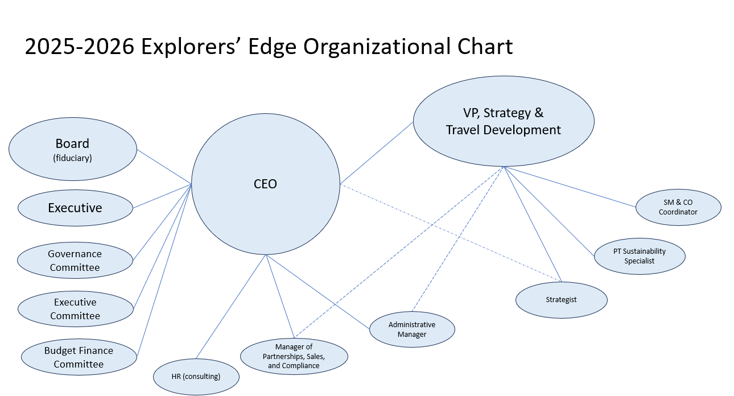

Current Staff
CEO: James Murphy
After completing a college diploma in Hotel & Resort Management, James did an undergraduate degree at the University of New Brunswick with a Bachelor of Applied Management in Hospitality & Tourism in 2004. In 2008 James received his Master of Arts, Recreation and Leisure Studies, Tourism Planning and Policy degree from the University of Waterloo. Post-graduation, James served as the general manager of Savour Muskoka, a culinary tourism initiative aimed at bridging the gap between supplier and restaurant chef while at the same time creating a culinary identity for the region of Muskoka and Parry Sound. During this time, he was involved in tourism initiatives on district and provincial levels, and was a Board member with Muskoka Tourism, the Ontario Culinary Tourism Association (OCTA) and the Muskoka Lakes Chamber of Commerce. James has also worked on projects with the Canadian Tourism Commission (now Destination Canada), Canadian Relais & Chateaux Association and Statistics Canada. James joined EE in 2011 as Executive Director, and was promoted to CEO in 2022. He is responsible for stewarding strong governance and administrative procedures, for procuring significant revenue and investment to support EE’s Regenerative Tourism Strategy, and for establishing the incorporated non-profit as one of Canada’s leading destination development organizations.
Vice President, Strategy & Travel Development: Kate Monk
Kate holds a Bachelor of Arts (Hons) from the University of Toronto. She also earned post-graduate certificates in public relations and media copywriting from Humber College in Etobicoke, Ontario. In 2021 she earned her Professional Certificate in Sustainable Tourism from the Global Sustainable Tourism Council, and in 2022, she earned sustainability certificates from the University of Toronto’s Rotman School of Management, and at Cambridge University’s Institute for Sustainability Leadership. She also completed the Ready, Set, (Re)Build course from the Ontario Non-Profit Housing Association. In 2023 she obtained the Transformational Travel Designer Certificate from the Transformational Travel Council, and in 2024 she completed the MBA Essentials course at Rotman. A supporter of many arts organizations, she is honoured to serve on the Board of Directors for Muskoka Arts & Crafts. Kate joined EE in 2011 and has been responsible for the creation of its innovative strategies and programs, including the company’s regenerative initiatives.
Administration Manager: Erin Smit
Erin holds a BA in sociology from Laurentian University and a diploma in Hotel & Resort Operations from Georgian College in Barrie. She joined EE under a one-year FedNor contract in 2012, and then joined the team permanently. She is the lead on project management for most undertakings at the company, and for operator outreach. Erin also acts as the organization’s office administrator.
Social Media & Content Development Coordinator: Jake Good
A journalist by training, Jake has an extensive background in social media management and content development, most recently in the craft brewing industry. He will be out of the office more than he’s in it, hitting the road soon to start telling the wonderful stories of the regional tourism sector.
Part-Time Sustainability Specialist: Rebecca Francis
Rebecca has an extensive background in corporate and social sustainability, environmental education, stakeholder engagement and project management. She has held sustainability positions in the non-profit, public and private sectors, and she holds an MES in Environmental Studies.

Explorers’ Edge Vision, Mission and Mandate:
Vision – EE is a Destination Development Organization that leads the Canadian tourism industry in regenerative development, ensuring that the region’s communities and tourism stakeholders are resilient and able to thrive long-term.
Mission – EE’s mission is to steward the regional tourism industry’s recovery, rebuild and renewal by developing innovative regenerative programs to ensure long-term sustainability and success for all stakeholders.
Mandate:
- Steward / Lead
- Research / Innovate
- Recover / Build
- Sustain
- Train
- Collaborate
Explorers’ Edge Guiding Principles:
- Develop regenerative strategies, programs and products that are the result of “out of the box” thinking, innovation and strategic collaboration.
- Use strategy, process and “the business of tourism” as guiding beacons to ensure the sustainability of the organization, tourism stakeholders and connected communities.
- Prioritize industry, stakeholder and community communications.
Explorers’ Edge Operating Principles
- Lead the recovery and rebuild as the regional Destination Development Organization
- Build programs and initiatives using the lens of regenerative business thinking.
- Leverage significant strategic partnerships.
- Engage various direct and indirect stakeholders to ensure wider sustainability and growth.
- Build revenue generation for the long-term sustainability of the organization and the regional industry.

Industry Scan:

Provincial Travel Indicators
Prior to the pandemic, visitation and spend results from the Research Unit of the Ministry of Tourism, Culture & Sport showed that domestic travel to the region remained strong up until the last year reported (2019):

Explorers’ Edge Estimated Visits:
- 2008: 3.5 million visits
- 2010: 3.8 million visits
- 2011: 4.8 million visits
- 2012: 4.1 million visits
- 2013: 4.3 million visits
- 2014: 4.3 million visits
- 2015: 4.4 million visits
- 2016: 4.7 million visits
- 2017: 4.5 million visits
- 2018: 3.7 million visits
- 2019: 4.4 million visits
- 2020: 2020 the industry did not receive a complete year of visits and spending at the regional levels
- 2021 4.4 million visits
- 2022: 4.4 million visits
Explorers’ Edge Estimated Spending:
- 2008: $662 million in spending
- 2010: $513 million in spending
- 2011: $598 million in spending
- 2012: $596 million in spending
- 2013: $614 million in spending
- 2014: $589 million in spending
- 2015: $699 million in spending
- 2016: $778 million in spending
- 2017: $650 million in spending
- 2018: $884 million in spending
- 2019: $840 million in spending
- 2020 the industry did not receive a complete year of visits and spending at the regional levels
- 2021: 1 billion in spending
- 2022: 1.3 billion in spending
Explorers’ Edge Businesses:
- 2008: 1,738 establishments
- 2010: 1,688 establishments
- 2011: 1,666 establishments
- 2012: 1,757 establishments
- 2013: 1,795 establishments
- 2014: 1,905 establishments
- 2015: 1,921 establishments
- 2016: 1,931 establishments
- 2017: 1,958 establishments
- 2018: 1,965 establishments
- 2019*: 841 establishments
- 2020: N/A
- 2021: 876 establishments, tourism related
- 2022: 879 establishments, tourism related
*2019 onward statics did not include “Retail” & “Other Services”, which accounted for 1,101 establishments in 2018.

Occupancy Data
Occupancy data for regional accommodations for the eleven months ending in November 2024 showed that this region continued to have a strong performance despite a challenging socio-economic environment (persistent Covid infections, price of gas, cost of living, inflation, etc.). Of note, EE is working to expand representation in the data set collection and hopes to include more regional properties in the upcoming fiscal, particularly in additional sub-regions.
Figure 2. CRBE Eleven Months Ended November 2024

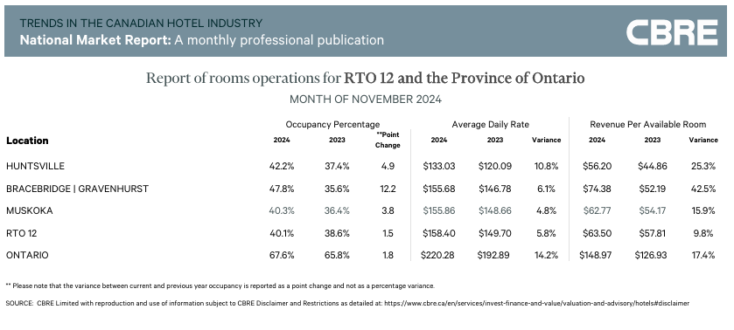

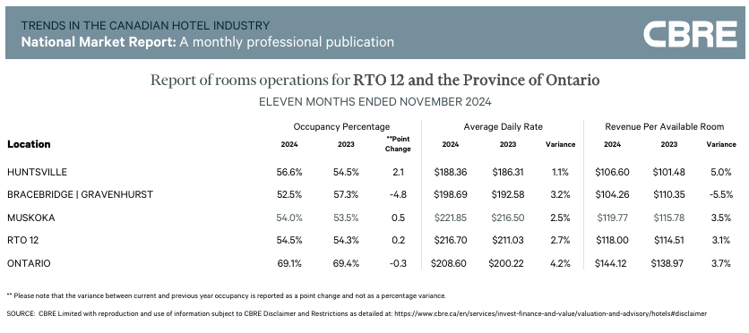

Historical Occupancy Review: 2008 – 2022

Figure 3. Historical Occupancy Review: 2008 - 2022
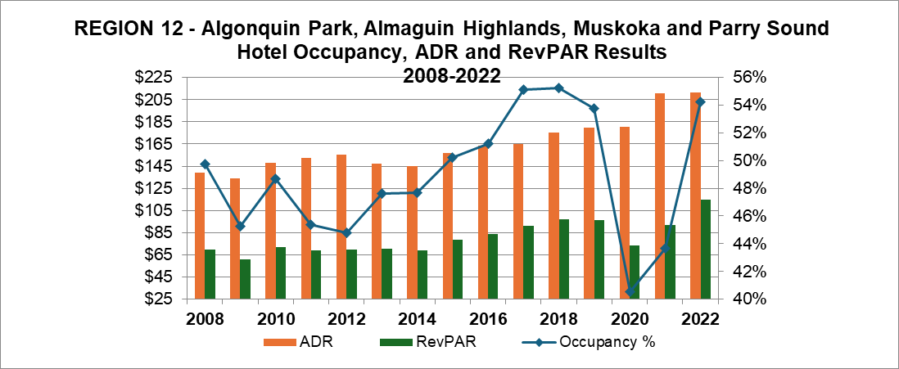

Macro Environment
According to Quarterly Reports by Skift Advisory commissioned by EE, the following statistics highlight the current state of the Ontario tourism industry:
Increased Travel Costs: The price of tourism-related activities, including accommodations, airfares, and dining, rose substantially, with a 19% increase in tourism consumer prices compared to 2019. This has led travellers to get less value for their spending, impacting both domestic and inbound tourism.
Rise of Domestic Travel: Canadian residents have been travelling more within the country, partly offsetting the decline in foreign visitors. Domestic demand remains a critical driver of tourism spending.
Shortfall in International Travel: International arrivals, especially from East Asian countries like China, Japan, and South Korea, remain significantly lower than pre-pandemic levels. Geopolitical factors and higher travel costs due to disrupted flight routes have contributed to this decline.
Economic Pressures: With rising interest rates and high household debt, costs have suppressed discretionary spending, incl. travel. However, easing inflation and recent interest rate cuts may improve consumer confidence and spending capacity.
Additionally:
- Ontario’s tourism sector spent $29.1 billion during the first nine months of 2024, a 4.8% increase compared to the same period in 2023. While the growth continues, the pace is slower than the post-pandemic surge seen last year, suggesting that the initial rebound is stabilizing.
- The first nine months of 2024 show a 2.2% decline in international spending (improving from a 4.5% decline in the first 6 months) totalling $10.1 billion. However, spending grew by an average of 3.9% per year since 2019, showing long-term recovery, although short-term factors like global economic uncertainty and competitive pressures dampen growth.
- With a 9.0% increase (up from 7.7% in the first 6 months) to $19.0 billion, domestic tourism remains a cornerstone of Ontario’s tourism economy. The growth reflects strong local engagement and a preference for regional travel.
- Ontario saw a steady increase in spending throughout the first nine months of 2024 compared with the same period in 2023. September growth was however the slowest it has been this year, indicating some cause for concern for the Winter season.
- Growth in 2024 has been inconsistent, peaking in March 2024 at 11% higher than March 2023 but flattening out in January and May 2024. This suggests strong growth momentum in the spring, likely driven by increased travel activity, improving weather, and possibly successful tourism campaigns or events.
- When comparing 2024 spending with pre-pandemic levels in 2019, the data shows consistent growth across all months. This is evident even in the September slowdown, indicating consistent long-term recovery.

Region Specific Data/Skift Advisory:
- Tourism spending in Explorers’ Edge is dominated by intra-provincial travellers, who contribute 82% to total spend. This spending increased by 6.6% over the past year and by 8.7% on a 5-year growth average.
- Inter-provincial travel spending recovered YOY with a 26.5% increase from 2023 to September 2024.
- International spending contributes almost as much as US, and surpasses Inter-provincial spend.
- The largest area of growth from 2023 to 2024 in terms of percentage growth is represented by Inter-provincial spend.
Additionally, the recent presidential election in the USA has resulted in an even lower Canadian dollar, and the threat of tariffs and a resulting trade war could stem outbound travel to the U.S. (resulting in increased domestic visitation), while potentially increasing inbound American arrivals (who benefit from a favourable exchange), or Europeans and other international travellers (who prefer not to travel to America during the significant administrative changes). With the exception of the luxury market, all these pressures have resulted in a decrease in leisure spend by most domestic travellers, a trend that is likely to continue until geopolitical and socio-economic situations stabilize (including federal and provincial election outcomes in 2025).

Climate Impact
The Canadian wildfire season that plagued summer occupancy in 2023 (dangerous levels of smoke from out-of-province fires) did not recur in 2024. Likewise, the poor starts to the previous three winters did not recur in late 2024 or 2025; this was due to lake effect snow from Georgian Bay rising in temperature, as well as the onset of La Nina in January 2025. Many parts of the region endured a 3-day winter storm starting on November 29, 2024, which dumped 4 feet of snow in approximately 4 hours. Winter operators are very happy, needless to say (!), as their revenue was precarious the last few years. None-the-less, annual temperatures continue to rise, and weather-related challenges are more likely to occur than not. As seen by the devastating fires in Los Angeles in January of 2025, in addition to the damage from environmental factors, insurance companies are developing policies to mitigate losses against what they have determined will be a climate-challenged business sector, due to unavoidable changes in temperature. EE continues to track this data, and to encourage operators to consider developing non-weather dependent, diversified product.

Regenerative Review: Staying the Course in an Uncertain World
In 2021, EE embarked on an ambitious “Region-Centric Regenerative Tourism Approach” to create innovative solutions for industry sustainability, wider community development, and organizational sustainability (see BOP21-22).
Since that time, it is important to note that Destination Canada launched its own regenerative tourism strategy, which aligns with the principles set earlier by Explorers’ Edge. In 2023, Destination Canada hosted its first International Stewardship Symposium, which focused on regenerative strategies for the global tourism industry, and the organization’s second round of intake for the regenerative “corridor strategy” took place in 2024.
In F24-25, EE continued to build its regenerative programs, particularly with the development of the OTA business model (Q4 F24-25…being finalized as BOP submitted), and also by instigating community Co-Creation sessions for sub-regional product development. The establishment of well-integrated networks of stakeholders seeking “mutually beneficial and symbiotic” relationships is essential to developing traditional and experiential product in these areas; co-creating product with communities will ensure grassroots development is successful, and also ensure that community stakeholders themselves have collective ownership of and accountability for optimal program outcomes.

Figure 4. Region-Centric Regenerative Tourism Approach, 2021
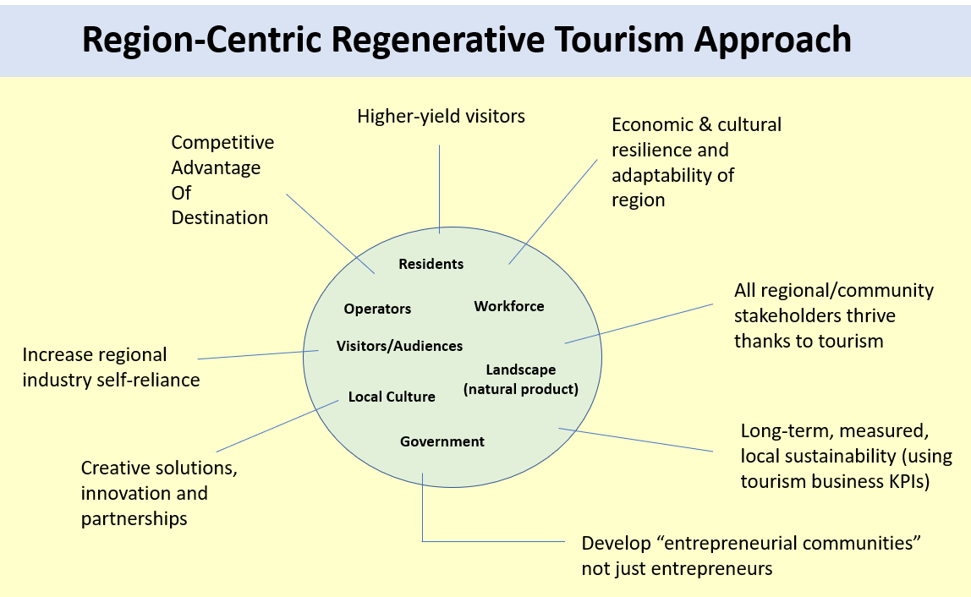
Within the circle are the community stakeholders.
Outside the circle are the intended outcomes of the region-centric regenerative approach.

The key pillars of the EE regenerative approach are:
- Work to ensure the economic, social, cultural, and environmental resilience of the region through tourism development.
- Consider and weigh the desires and needs of all community stakeholders – not just those involved directly in the tourism industry, nor only those in ownership positions.
- Increase regional self-reliance to solve local challenges and increase revenue generation to stabilize and develop the tourism industry.
- Seek and implement creative solutions, innovation, and strategic partnerships to solve community development and industry sustainability challenges. Develop timely research and attract digital and tech innovation for the industry.
- Develop KPIs to reflect improvement of the tourism industry in relation to economic, social, cultural, and environmental objectives (a holistic measurement).
- Concentrate on developing higher-yield visitation (spend more, stay longer in the region) rather than on mass tourism.

- Build an extremely robust communications plan to promote the ongoing development of the regional tourism business ecosystem.

- Position EE as a Destination Development Organization that champions ‘the business of tourism as a catalyst for thriving communities.’
As part of this approach, BOP2021-2022 outlined pillars of work in addition to the ones established by the MTC&G in the TPA. These include regenerative community development and revenue generation. Over the course of the past year and into F25-26, the work pertaining to these pillars have become more entrenched, with positive outcomes expected.

Figure 5. Destination Development Organization
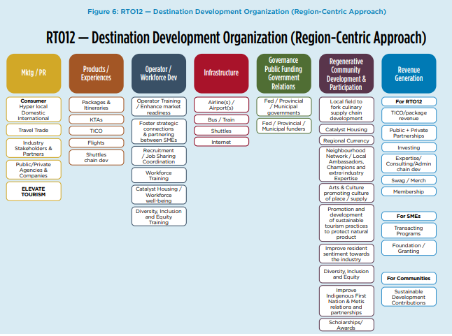

Priority Projects: 2025-2026
1. Revenue Generation
The CEO, VP of Strategy & Travel Development and Revenue Manager will instigate multiple programs to increase the funding for organizational, sectorial and community sustainability. Projects such as monetizing the Summit registration, sponsorships for EE’s events, potential advertising revenue, and consulting fees will be considered for implementation. Additionally, the OTA is intended to introduce sustainable revenue generation as well. The new Budget & Finance Committee will assist in strengthening fiscal processes.
2. Operationalizing the Regenerative Travel Agency (OTA)
EE was awarded its TICO license in June of 2024. The organization had hoped to launch the project within the same fiscal year, but changes to Board membership (requiring new onboarding) and orientation for staff by TICO required a changed timeline, as did the necessity to hire dedicated staff (Revenue Manager). The OTA will launch in F25-26, with potential high yield opportunities identified for testing, and package offerings scaled up over time.
3. Sub-Regional Product Development & Co-Creating Community Ecosystems
In F24-25, EE commenced experiential product development in underfunded and under-resourced sub-regions. This work will continue, including conducting co-creation labs to ensure positive buy-in and “ownership” from networked stakeholders in these areas.
Product Development is a major priority of EE moving forward, as differentiated product is required to compete for customers, and to build customer loyalty for the OTA and the region.
4. Investment Attraction (Air Canada regional route testing)
In Q3 F24-25, EE began meeting with regional route development representatives from Air Canada and Landlines about the potential for partnering to bring leisure visitors to the region via their innovative luxury coach service. These discussions continued into Q4, and the project will be tested in F25-26. The appetite for this project is that, in addition to servicing customers from international and domestic origins, service can also be offered more often than via regional air, including in the winter (when it is harder to get people to travel on major highways). EE will play a lead roll in the region to market to international and inter-provincial audiences, to bring new revenue to the region and to the province.
5. Differentiated Marketing for Higher Conversion
In F24-25, identifying consumer social media fatigue as well as significant duplication by tourism marketers (locally, regionally, provincially, federally, and globally), EE tested various new-to-us channels and data opportunities to determine a differentiated strategy for developing leads for the OTA. EE will build some of the associated tactics into its overall Marketing Plan in F25-26, including (eventually) opportunities to use A.I. for greater efficiencies (though not at the cost of optimal engagement). See Marketing Plan.
6. Local Workforce Training Development
In F24-25, EE identified the opportunity to switch tack for developing the Catalyst Housing project, as housing became more and more of a priority for other municipal and provincial stakeholders (including those now issuing community bonds). With labour gaps still a major concern for operators; with revised federal government policies now hindering the hiring of temporary foreign workers, immigrants or students; and with local residents now identified as the biggest opportunity to fill the gaps, EE has commenced discussions with a local employment centre and a sub-regional economic development team to create a pipeline of individuals who live, train and want to have more secure employment in the region. Successful participants of the training will be paired with regional employers for work-integrated learning opportunities, and housing stability will remain a potential key offering for successful completion of the training of the program. The training will also look at A.I. and Content Management Systems to link all stakeholders in to a localized workforce eco-system.

Explorers’ Edge 2025-2026 Government Pillars
The current mandated pillars by Ministry of Tourism, Culture & Gaming for EE to work within and provide measurable outcomes include the following:
Product Development – to enhance visitor experience through well-designed tourism products that meet current and future visitor demand.
EE will prioritize event and experience development in the lesser-funded sub-regions (Almaguin Highlands, Loring-Restoule, west Parry Sound district, and South Algonquin), which do not necessarily have the capacity (e.g. staff, funding) to compete against more resourced destinations in Ontario and Canada.

Using the Co-Creation Lab to foster more robust networks for development and prioritizing product development opportunities for the Partnership Fund, EE will create new and enhanced product to attract visitors to and spending in these sub-regions. EE will continue to identify economic reconciliation opportunities through cultural product development with Indigenous communities.

Investment Attraction/ Investor Relations – to increase investment in the tourism industry to enhance visitor experience.
As noted in the Value for Money Audit: Tourism Support Programs (December 2023), many RTOs do not have enough funds to exponentially increase investment in their regions, and arguably, Explorers’ Edge is one of them. Rural destinations, in particular, are challenged to compete against more heavily funded regions, such as Niagara District, Toronto, and Ottawa.

Nonetheless, EE will work to attract major transportation partners to the region, including Air Canada, The Northlander train, and Great Lakes cruise operators (via continued investment in the Town of Parry Sound’s cruise strategy).

Workforce Development and Training – facilitate and support the attraction, development and retention of a tourism workforce to enhance the visitor experience.
Workforce development is the priority of the EE board, and staff continue to work on many projects to solve what is a global challenge for the tourism and hospitality sectors, including training and housing development, the Big Applause Awards employee excellence recognition, Women in Tourism events, industry job board, high school development, and more. (See priority projects above for details.)
Marketing – to increase awareness of Ontario as a travel destination and increase conversion in target markets.

See Marketing Plan. Much work has been done to test efficiencies and efficacies to build awareness of the region and to increase high yield conversions.

Partnership – to become a catalyst in building strategic alignment and promoting collaboration within the industry.
EE will prioritize product development projects for alignment with the overall regenerative tourism strategy, and to develop offerings to attract visitors in a highly competitive market. Event and experiential product development will be key for the sub-regions that do not have as highly-developed infrastructure or funding, and EE staff will work collaboratively with stakeholders to co-creation successful product.

Additional – Industry Communication, Liaison and Accountability
EE continues to update the industry annually via industry newsletters, and in Q3 F24-25, EE launched its corporate Instagram account to provide more immediate updates. EE will be doing much more in-person subregional work to help develop product and will continue to host town halls to communicate the deliverables in the BOP. EE will host an annual AGM, as well as the annual Regional Tourism Summit.

High Level Goals for Each Pillar
Consumer Marketing - $175K
- Regional Content Marketing
- OTA Marketing
- Digital Asset Management/Development
- Ad Trafficking
- Strategist
- Work with Destination Ontario broadcast and product leads
- Consumer Website updates

Product Development – $60K
- Test & assess potential high yield affinity product (e.g. luxury, pet-friendly, resorting, golf, experiences for new Canadians/urban dwellers etc.)
- Experiential Product Development
- Angling
- Motorcycle Touring
- Cycling
- Visiting Friends & Relatives
- Product Development Workshops (Co-Creation Lab)
- Product Content
- Sustainability
- Indigenous Cultural Tourism

Investment Attraction – staff resources
- Work with Town of Parry Sound on Great Lakes Cruise strategy
- Air Canada Landlines Luxury Coach Program
- Northlander train service (packages, itineraries, last mile)

Workforce Development – $15K
- Big Applause Awards
- Women in Tourism Events
- Catalyst Housing – multi-partner training development and tech optimization
- Regional Tourism Job Board

Partnership – $166K
- Product Development prioritized
- Workforce and Marketing programs

Industry Relations – $31K
- Regional Tourism Summit
- Membership
- Corporate Website
- Committee Meetings
- Educational Webinars
- Newsletter deployment
Research - $38K
- Survey Platform
- Canada Travel collective
- Research Programs (CBRE, Skift Advisory, Environics)
- Strategist

Partnership - $166K
- Support Product Development projects that align with EE objectives.
- Enhance marketing strategies that align with Explorers’ Edge outcomes.
- Encourage programs that address labour shortages, upskill employees and foster improved workplace conditions.

Explorers’ Edge Consumer Marketing Plan
Summary

EE’s main focus will be on building captive audiences and leads for the OTA, while continuing to promote core items (stay, eat, do categories) with general content marketing. A longer-term objective is to build destination loyalty and increase the number of repeat visitors, as well as visitors who recommend the region/products.

The EE Travel Lounge is a branded content hub where targeted audiences can find value-added travel info pertinent to their particular interests (‘affinity experiences’). The hub will use more personalized tactics for engaging travel planners, such as Zoom information sessions, expert demos and encounters, podcast episodes, direct response mailings/collateral, membership (via digital or social platforms), incentives/giveaways, phone inquiries (travel concierge), in-person events/pop ups, and any additional tactics to create awareness of the region/product or to meet them in-market (purchase funnel).

The overall goals of the marketing program are to:
- build awareness of product and region
- inform planners with engaging content
- complete purchase (then repeat/loyalty)
- Co-create compelling and value-added content with individual stakeholders
The OTA and Travel Lounge are intended to increase visitation, spend and purchase for the regional catchment, but additional regions of Ontario will potentially benefit from the program, particularly for overseas markets, thereby increasing visitation and spend across the province. Additionally, individual operators, eco dev departments, DMOs will have the opportunity to co-create engaging content for promotion, with the aim of EE developing revenue generating buy-in programs for these stakeholders to take advantage of.
With the mantra of “personalize and engage for conversion”, EE will differentiate itself in the marketplace and avoid significant digital and social media promotional duplication. The aim is “differentiation not duplication.”

Of note:
- Rather than delineate target audiences by geographic markets (hyper local, domestic, international), EE will instead target audiences based on affinity experiences, no matter where they reside. If the target is pet-owners seeking pet-friendly accommodations and experiences, the marketing will appeal to the target’s affinity for pet-friendly travel, no matter where their point of origin. This is important, as geopolitical instability currently requires pivoting often and abruptly depending on current events and destination of origin. Targeting affinity audiences means the path to purchase is more likely, regardless of where a traveler is starting from or what is happening in the world/Ontario/Canada.
- Given the geopolitical and fiscal uncertainty since the US election, EE will commence targeting inter-provincial markets to develop its long-haul domestic traveler segment. EE will also target overseas markets, and will test AI functionality to translate content. EE sees an opportunity to develop audiences from Quebec (despite the necessity for translation). It is also a good year to target Canadians as the dollar is low, inflation is high, cost of living is challenging, and Canadians face a lot of uncertainty politically.
- EE will continue to work with domestic and northern reps from Destination Ontario to align marketing efforts for optimal efficiency and efficacy. The outcomes of the TICO Readiness Report (F24-25) include DO and EE fine-tuning mutually beneficial outcomes, and with content marketing, tracking the far more important indicator of “engagement”, rather than impressions or landing page clicks from ads (high volume/low quality traffic).
- GA4 is the main tool for analyzing engagement and optimizing marketing tactics for greater likelihood of conversion. Collaborating partners will be asked to provide analytics to deepen EE’s intelligence gathering for optimal outcomes.
- In addition to OTA and core content marketing budget delineation, EE has allocated funds for product marketing of experiences developed in collaboration with identified sub-regions.
- EE staff will be increasing in-house creative content exponentially to feed the “membership” value-added offering. Membership/leads will be built via social and digital platforms; email marketing will be eliminated for general lead mining (still used to communicate with travelers further down the purchase funnel).
The following is a summary of the BOP25-26 implementation priorities, as well as objectives, key activities, timelines, and targeted performance measures for MTC&G TPA requirements.
Note: All performance indicators are considered targets only.

2025 - 2026 Business & Operational Plan Summary
Governance | Marketing | Product Development | Investment Attraction | Workforce | Partnership
166K | 175K | 60K | Staff Resources | 15K | 166K
Govern EE through effective leadership; strong equitable industry representation; and execute optimal governance, strategies and process. Hold AGM. Establish Budget & Finance Committee to refine fiduciary processes.  Ensure organizational decisions meet the needs of both the tourism business community and the community as a whole to “float all boats” (including tourism SME’s, employees, and residents)  Share tourism sustainability program outcomes, regenerative program development and destination development updates.  Consult industry and community stakeholders; conduct regular outreach; conduct Co-Creation Lab sessions to ensure stakeholder input and buy-in.  Expand team to meet objectives; hire new Revenue Manager. | Identify/target high yield “affinity” audiences for experiential and traditional tourism product.  Target identified affinity audiences hyper-locally, provincially, inter-provincially and globally.  Introduce “personalization & engagement” tactics to optimize conversion and to distinguish region in the marketplace.  Identify/implement lead nurturing and destination loyalty through alternative membership forums. Product value-added content for these forums.  Develop innovative marketing partnerships and leverage affinity marketing (business partnerships) for more targeted reach and more likelihood of conversion.  Produce ‘always on’ content to serve the greater industry. | Build regenerative travel agency for launch; develop high yield packages and itineraries for purchase.  Collaborate with sub-regional stakeholders to build experiential product.  Enhance traditional product (e.g. angling, cycling, resorting, VFR, golf, outdoor adventure, arts & culture) and partner for affinity marketing programs.  Partner with DO for broadcasting and content opportunities that align.  Develop sustainable tourism properties by building sustainable stewardship educational initiatives, and work directly with operators to improve their sustainability practices (EE Sustainability Strategist).  Continue to work with Indigenous stakeholders to develop authentic cultural experiences.  Develop VFR initiative. | Explore partnerships & investing that prioritizes regenerative tourism and workforce development.  Communicate to communities & impact investors re investment opportunities. Update website with video assets to explain our work.  Explore a tourism business case for passenger rail service; continue to connect with Northlander marketing representatives.  Continue as a member of the Great Lakes Cruise Coalition ensuring a robust cruise network; build dispersion of passengers into Parry Sound.  Work with Air Canada to introduce regional coach service to the region.  Research and introduce leisure travel transportation options (cross regional transport/last mile). | Update and promote Regional Job Board.  Develop and launch 4th annual Big Applause Awards.  Book insightful guest speakers and panelists for the Regional Tourism Summit.  Work with sub-regional employment agency and local eco dev reps to test and build training pipeline, from pre-employment to sustainable work in the regional industry.  Conduct ongoing, timely and region-centric industry research. Launch the annual Business Confidence Index and the Catalyst Housing revise operator survey (include wider regional stakeholders in additional to Huntsville). | Prioritize partnerships that support Explorers’ Edge’s regenerative tourism and workforce development initiatives.  Prioritize product development.  Continue to work with local stakeholders to examine mutually beneficial regional partnerships opportunities.  Consider non weather-dependent events and program in Spring and Winter.  Connect with local FN stakeholders to work towards economic reconciliation via ‘the business of tourism.’

2025 – 2026 BOP: Objectives, Key Activities and Timelines, Performance Measures

Governance
Priority / Strategic Focus | Objectives | Key Activities / Tactics | Performance Indicator
Governance and Administration
Governance
Govern EE through effective leadership; strong equitable industry representation; and execute optimal governance, strategies and process. Hold AGM. Establish Budget & Finance Committee to refine fiduciary processes. | Ensure Board runs efficiently and effectively, and that Directors and stakeholders are informed about and benefitting from EE’s regenerative destination development initiatives. | Update the Board (minimum) quarterly and request thorough review and input on YTD BOP execution. Regularly review activities, finances at Board meetings.  Conduct Board reviews via surveys of RTO plans and performance measures against stated objectives and targets; adjust as required.  Conduct an annual, multi-stage strategic planning confirmation process. Conduct annual on-boarding sessions. | Number of quarterly updates provided to the Board (Target: 4 per year).  Percentage of Board members attending each update meeting (Target: 90% attendance).  Number of actionable inputs or feedback items incorporated from Board reviews (Target: Minimum 3 per quarter).  Number of financial and activity reports reviewed by the Board annually (Target: Minimum 4 per year).  Number of new strategic objectives identified and adopted annually (Target: Minimum 2 new objectives).
Ensure organizational decisions meet the needs of both the tourism business community and the community as a whole to “float all boats” (including tourism SME’s, employees, and residents) | Ensure level playing field for all sub-regional stakeholders. | Encourage Board participation at sub-regional events/workshops.  Encourage Board champions to recruit new Directors that support the Regenerative Tourism Strategy. Continue governance training and diversity, inclusion, and equity training. | Number of sub-regional events/workshops attended by Board members per year (Target: Minimum 10 events collectively).  Percentage of Board members completing governance and DIE training annually (Target: 100%).
Share tourism sustainability program outcomes, regenerative program development and destination development updates. Consult industry and community stakeholders; conduct regular outreach; conduct Co-Creation Lab sessions to ensure stakeholder input and buy-in. | Communicate often and effectively to inform stakeholders and to solicit critical feedback on programs. | Development of committee(s) when necessary, that are inclusive to the community. | Percentage of committee members representing diverse community groups or perspectives (Target: 80% inclusion of underrepresented groups relevant to the community).
Priority / Strategic Focus | Objectives | Key Activities / Tactics | Performance Indicator
Operations
Hire Manager of partnerships, sales and compliance dedicated to more complex administration apropos the OTA and additional initiatives. | Assist the CEO in managing multiple revenue streams and reporting/accountability processes. | Monitor BOP and TPA deliverables and finances for successful completion.  Introduce and optimize revenue generation via corporate and consumer purchases (advertising, packages, etc.) and memberships.  Ensure the successful launch and scale up of the regenerative travel agency; monitor and refine Business Plan deliverables of the OTA.  Development of investment strategy, including communication, outreach and fulfilment.  Development of in-community regenerative investment by EE from new revenue streams, particularly the OTA. | Weekly meetings with the CEO, VP Strategy & Travel Development and Revenue Manager to ensure BOP deliverables are on target. (40 status meetings total annually.)  Create Budget & Finance Committee and include value-added members such as investment strategists, corporate lawyers, regeneration experts (for example) to provide critical feedback on operationalizing and optimizing the OTA to build sustainability for the region and the sector.  Launch OTA and generate (minimum) $60K in gross sales Y1.  Determine and support Y1 recipient(s) of partial OTA gross sales. (Minimum recipient). Award monetarily.
Work with HR consultant to ensure best practices. | Ensure professional standards are exceeded and a positive work culture is continually nurtured. | Semi-annual meet/plan with HR consultant to ensure best practices and high satisfaction office culture (employee retention) | Outcomes of staff performance evaluations  Two certificates completed by staff.
Secure bridge financing to ensure continued operations between TPA deposits. | Avoid temporary cessation of payroll and project funding. | Meet with finance and budget committee, present to the board of directors  Complete necessary processes with Community Futures. | Secure bridge financing by Q4.

Priority / Strategic Focus | Objectives | Key Activities / Tactics | Performance Indicator
Industry Communication, Liaison and Accountability
Host the 3rd annual Regional Tourism Summit | Distinguish EE as a leader in RURAL destination development.  Provide informative sessions/speakers/panels and exceptional networking opportunities.  Generate revenue | Begin planning in Q4 for November 2025 Regional Tourism Summit. Announce event early in Q1 F25-26.  Identify relevant speakers who are also not on the current Canadian/provincial conference/summit circuit. Invite speakers/participants to move forward facets of the regenerative tourism strategy and to bring new, helpful information to the podium.  Continue with value-added ticketed event and cover 100% of costs. | Media announcement re Summit Dates by April 1, 2025.  All speakers identified, engaged and booked by July 31, 2025. Conference details finalized by same date (accommodations, etc.).  Tickets launched and posted (all estimated costs assessed) by August 10. 100 tickets sold.
Corporate Website | Review and optimize corporate website for more streamlined communications. Use new Data Assets Management System to target increased media release output. | Add all current video and photo assets to the new Data Asset Management system. Create Media Centre for releases and assets to be deployed more readily. Invite operators and stakeholders to sign up for access based on standard needs. | 1 corporate media release per month on corporate initiatives posted once assets are loaded and tagged.  40 operators signed up in asset management system to access content for use.
Committee Meetings/Co-Creation Labs | Increase in-person sessions to foster greater reciprocal communication. Develop organic champions of regenerative tourism product and strategies. | Continue with annual Town Halls and increase number of sub-regional collaborative sessions particularly for experiential product development. Frame all work via the lens of the Regenerative Tourism Strategy. | 3 Town Halls  2 in-person sessions (minimum) per sub-region (excluding Muskoka) pertinent to product development
Educational Webinars | Help tourism businesses and staff be up to speed in latest industry trends and developments. | Book industry and extra-industry experts for helpful webinars. Sustainability Strategist will also conduct informative sessions either in person or by webinar. | 5 industry webinars (minimum)

Marketing
Priority / Strategic Focus | Objectives | Key Activities / Tactics | Performance Indicator
Marketing
Regenerative Travel Agency/Packages
Launch the OTA | Refine Business & Marketing Plans for the OTA and officially launch to attract high yield visitors to the region.  Test market ready product and scale up based on consumer and administrative feedback.  Introduce revenue stream to support regenerative initiatives and organizational sustainability. | CEO, VP Strategy & Travel Development, Revenue Manager and Budget & Finance Committee approve Go-To-Market Plan  Key partners and products identified for test marketing / selling. Customer feedback solicited throughout all purchase funnel touch points to strengthen and refine future offers.  Identify market value of packages (revenue model) and build in to accounting processes. Introduce purchasing functionality and travel info on the consumer website. | Launch by Q2 2025  5 packages launched (minimum) in Q2 for testing (promoting upcoming season). 10 packages launched in Q3 (promoting upcoming season). 10 packages launched Q4 (promoting the upcoming season).  10-15 operators participating.  100 packages sold.  Purchasing functionality imbedded in consumer website.
Build lead database and “membership” loyalty program | Create a lead generating program that is differentiated in the marketplace. | Officially launch the Explorers’ Edge Travel Lounge on the consumer website – a place for high yield affinity experience travelers to find content and access more intimate communication opportunities (e.g. podcasts, product/expert Zooms, and value-added content). | EE Travel Lounge Podcast launches Q3 2025 (October). Host (minimum) 6 “expert” Zooms.  Members only content section created on the website and on social channels (TBD but YT, IG or Patreon etc.)
Determine high yield audiences for “affinity product and experiences” | Eliminate targeting geographical areas and target “communities of interest / affinity audiences” wherever they are (local, provincial, federal, global) | Use GA4 analytics to determine high engagement and conversion and to identify potential high yield audiences. | 8-10 high yield affinity audiences targeted for conversion (package purchase).

Priority / Strategic Focus | Objectives |  | Key Activities / Tactics | Performance Indicator
Regenerative Travel Agency/Packages
Promote packages and itineraries (local product, pan-provincial product) | Launch digital and print (when ideal) campaigns to target high yield audiences |  | Content marketing promotion, affinity marketing with tourism businesses and additional B2B partners.  Create value-added content for in-market audiences (closer to purchase | Promote minimum 3 pieces of content per quarter with packages.  20 reels created and 200 images amassed for content promotion.
Introduce AI functionality for content marketing | Reach overseas audiences and markets in Quebec |  | Translate pertinent content using AI translation functionality | 10 pieces of content translated. Benchmark overseas engagement with content via GA4.
Engage broadcast media and product influencers to promote the agency and packages | Increase media exposure |  | Work with DO and other media partners to promote the new OTA and itineraries/packages | 1 broadcast opportunity with DO (minimum) completed  Product influencers engaged.
Priority / Strategic Focus |  | Objectives | Key Activities / Tactics | Performance Indicator
General Marketing
Content Marketing | Create awareness of regional product and travel experiences that don’t have an associated OTA package available. |  | Traffic developed content over social media channels monitoring, updating, and responding to travel enquiries related to posted information.  Update social media channels with information related to regional product and experiences.  Respond and interact with travel enquiries across multiple social media platforms. | 3 pieces of content (minimum) promoted per quarter.

Product Development
Priority / Strategic Focus | Objectives | Key Activities / Tactics | Performance Indicator
Product Development
Product
Experiential Product | Assist sub-regions with the development of experiential tourism product to foster competitiveness and community economic development in all four seasons | Conduct in person experiential development sessions (Co-Creation Labs) to identify and develop marketable product in AH, LR, SA and west PS. Conduct follow-up sessions by Zoom to solicit continuous intel and feedback. | 8 in-person sessions.  8 new experiential products developed or in development.  Cliff Valley Astro Party in AH developed and hosted in August 2025 in partnership with Almaguin Community Economic Development and local astronomy enthusiasts.
Angling | Develop and build audience for 4 season angling including novices and families | Tour Ron James Fishing and Pat Roach around the region to reach their massively engaged audience in Spring 2025. Promote activities for spouses and families. | 3-day tour completed in at least 2 sub-regions.  Social media assets (2-3 stops per day) posted, and engagement tracked.  Content tracked on EE assets.  DO Northern rep engaged to assist.
Motorcycle Touring | Increase day trip touring to the region and overnight stays from Ontario and Quebec. Promote the region as a gateway to riding in other parts of Ontario. | Work with DO Northern rep to build motorcycle tourism product and to test marketing.  Position EE region as gateway to motorcycle touring and to roads north of Powassan.  Target Ontario, US (NY only) and Quebec (test)  Affinity marketing with Moto Social (or other TBD) | Rally event organized in partnership with Moto Social or other and with local operators (accommodations, meals, entertainment). Spring or Fall event.  3 packages developed. Leads into Travel Lounge database.

Priority / Strategic Focus | Objectives | Key Activities / Tactics | Performance Indicator
Product
Cycling | Establish the region as the preferred destination in Ontario to tour (on road), train (endurance) and trek (off road). Promote 4 seasons. | Work with Ontario By Bike to collaborate on digital content.  Attend annual Velo Montreal Show with OBB  Assist with the development, launch and promotion of Great Waterfront Cycling Trail Muskoka-Parry Sound new leg  Replenish Bike Cottage Country website and integrate into GCW website and digital marketing  Launch innovative in-person “Pop Up Cycling Cafes” to hand out cycling materials, in partnership with local cafes and accommodations. | 3 packages developed. Leads into Travel Lounge membership.
Visiting Friends & Relatives | Introduce resident loyalty purchase program (regenerative) | Work with local community libraries to offer lending pass to local attractions & experiences. Target VFR of permanent and seasonal households. Market to lake association members. | 5 operators (minimum) participate in lending pass program for Spring/Summer/Fall with one municipal library (test and then scale if successful).
Sustainable Tourism | Increase amount of sustainability being practiced by regional tourism operators | Sustainability Strategist will develop introductory stewardship materials and complete operator site visits to assist operators in their sustainability journey. | 10 operators improve their sustainability footprint. 20 site visits (minimum) annually.
Indigenous Cultural Tourism | Continue to identify opportunities to support Indigenous cultural development | Work collaboratively with Indigenous stakeholders and nurture relationships by attending non-tourism events/educational sessions (e.g. Pow Wows). | Indigenous tourism development is measured in trust/nurturing rather than definitive outcomes.
Luxury Experiences | Create differentiated marketing to target High Net Income Travellers (HNIT) | Determine interested operators for collective, differentiate marketing via the Travel Lounge, targeting overseas markets. | Minimum 4 operators participate in test marketing.

Investment Attraction
Priority / Strategic Focus | Objectives | Key Activities / Tactics | Performance Indicator
Investment Attraction
Communication
Key Messaging | Ensure EE’s priorities and opportunities are broadcast to reach potential investors | Update website to ensure investment attractions projects are prominent and so that potential investors are well informed re opportunities with EE | Website updated by Summer 2025 with dedicated section on navigation.
Transportation
Build opportunities for increased dispersion via transportation opportunities. | Increase accessibility via multiple modes of transport (air, bus, train, etc.), | Work with the Northlander’s marketing team to develop an innovative marketing strategy and to prepare for package development and sales.  Support the Great Lakes Cruising Coalition (GLCC) and  the Town of Parry Sound economic development team to attract cruise lines and to pitch overnight excursions.  Work with Air Canada and CYQA to introduce AC’s luxury coach service to the region. | Marketing proposal prepared by November 2025.  Shuttle service supported. Chamber of Commerce information tent supported.  In-market testing by July-August 2025. Confirmed service for F26-27 by November 2025.

Workforce
Priority / Strategic Focus | Objectives | Key Activities / Tactics | Performance Indicator
Workforce
Training development and testing in the Almaguin Highlands. | Work with sub-regional stakeholders to create tourism industry employment pipeline. | Partner with sub-regional employment agency that currently runs pre-employment and high school completion training to expand the offering into work-integrated training. Further partner with sub-regional economic development team to link businesses to potential employees. | EE and sub-regional stakeholders have mapped out a training path and initial participants underway by Q4.
High School Development | Create funding opportunities to enhance programming, through OTA revenue or by facilitating industry support. | Determine industry interest to support enhanced programming and work-integrated training. | 6 sub-regional high schools supported
Job Board | Promote current job openings. | Update Job Board regularly and promote. | Job listings updated seasonally.
Big Applause Awards | Reward employee excellence to promote the retention of regional workers. Promote industry as great place to work. | Host 4th Annual Big Applause Awards and Luncheon. Publicize winners. | 30+ nominees awarded. Media coverage of employee excellence.
Women in Tourism | Support women in their tourism & hospitality careers and attract more workers (they make up most of the workers in the region) | Host minimum 2 events annually. Partner with industry colleagues to co-present. Host engaging speakers. Foster mentorship initiatives. | 70 women participate in the annual Summit event.

Partnership
Priority / Strategic Focus | Objectives | Key Activities / Tactics | Performance Indicator
Partnership
Establish collaborations with partners who prioritize and support product development initiatives that align with the priorities and goals of the Regional Tourism Organization (RTO), while simultaneously empowering underfunded sub-regions. Further, align communication and marketing strategies to enhance these initiatives, fostering a cohesive approach to regional development | Support the development of innovative tourism products in underfunded sub-regions, creating unique visitor experiences that drive economic growth and enhance regional appeal.  Facilitate economic opportunities for underfunded sub-regions by prioritizing product development initiatives that contribute to regenerative economic development, complemented by targeted marketing efforts.  Encourage partners to align their efforts with the RTO's goals by focusing on product development and promoting regenerative tourism practices through coordinated communication and marketing strategies. | Leverage internal staff resources to effectively communicate the operational plans, strategies, objectives, and outcomes of the organization.  Distribute partnership criteria and the corresponding process to stakeholders within the region.  Collaborate with third-party entities to develop comprehensive partnership work plans, outlining key deliverables and establishing timelines.  Utilize internal staff resources to communicate mid-partnership progress updates and present the final report to both the board of directors and relevant stakeholders. | # of communication and partnerships (goal and target – 12)

Fiscal 2025 / 2026 Budget
Budget Items | Q1 | Q2 | Q3 | Q4 | TOTAL
Governance and Administration
Salaries & Benefits | 42,263 | 42,263 | 42,262 | 42,262 | 169,050
Governance | 1,500 | 1,500 | 1,500 | 1,500 | 6,000
Overhead / Facilities | 16,500 | 16,500 | 16,500 | 16,500 | 66,000
Finance and Administration (Accounting, Audit, Legal) | 9,889 | 9,889 | 9,889 | 9,889 | 39,557
Travel | 10,625 | 10,625 | 10,625 | 10,625 | 42,500
Industry Relations / Stakeholder Engagement | 2,500 | 2,500 | 2,500 | 2,500 | 10,000
Information Technology | 10,000 | 15000 | 2500 | 2,500 | 30,000
SUBTOTAL |  |  |  |  | 363,107
Product Development
Salaries & Benefits | 10,000 | 10,000 | 10,000 | 10,000 | 40,000
Product Development Enhancements | 20,000 | 20,000 | 10,000 | 10,000 | 60,000
Research | 20,000.00 | 10,000.00 | 6,000.00 | 2,800.00 | 38,800
SUBTOTAL |  |  |  |  | 138,800
Marketing and Promotion
Salaries and Benefits | 48,750 | 48,750 | 48,750 | 48,750 | 195,000
Markeitng - Regional Content | 20,000 | 10,000 | 5,000 | 5,000 | 40,000
Marketing - Regenerative Travel Agency | 30,000 | 10,000.00 | 15,000.00 | 5,000 | 60,000
Website Updates | 10,000 | 10,000.00 | 5,000.00 | - | 25,000
Marketing Asset Development (zooms, video, photos, content, contests, incetnives) | 15,000 | 5,000 | 2,500.00 | 2,500 | 25,000
Project Mgmt. Ad Trafficking | 6,000 | 3,000 | 1,500 | 1,500 | 12,000
Strategist | 3,000 | 3,000 | 3,000 | 4,200 | 13,200
SUBTOTAL |  |  |  |  | 370,200
Investment Attraction
Salaries & Benefits | 5,000 | 5,000 | 5,000 | 5,000 | 20,000
SUBTOTAL |  |  |  |  | 20,000
Workforce Development
Salaries & Benefits | 8,750 | 8,750 | 8,750 | 8,750 | 35,000
Communication, Training & Outreach | 5,000 | 5,000 | 2,500 | 2,500 | 15,000
SUBTOTAL |  |  |  |  | 50,000
Partnership
Salaries & Benefits | 10,000 | 10,000 | 10,000 | 10,000 | 40,000
Product Development | 50,000 | 25,000 | 25,000.00 | - | 100,000
Workforce Development | 5,000 | 5,000 | - | - | 10,000
Marketing | 25,000 | 20,000 | 6,000.00 | 5,000.00 | 56,000
SUBTOTAL |  |  |  |  | 206,000
TOTAL AGREEMENT COSTS |  |  |  |  | 1,148,107

